Architectural Paradigms for Short-Term and Long-Term Memory in Conversational AI Systems

The Stateless Illusion and the Cognitive Taxonomy of Agent Memory
Large Language Models (LLMs) are fundamentally stateless mathematical functions¹. Every application programming interface (API) invocation executes an isolated forward pass over a fixed array of input tokens, possessing no intrinsic persistence across requests¹. What appears to an end user as continuous conversational awareness is an engineered illusion maintained entirely by an external orchestration layer that captures, curates, retrieves, and re-injects historical state into every subsequent API payload¹.
A pervasive architectural misconception is that the expansion of transformer context windows—scaling from 8,192 tokens to 200,000 or 1,000,000 tokens—eliminates the need for dedicated memory architectures¹. Empirical production performance refutes this assumption on three fronts: economics, latency, and attention degradation¹. Because transformer self-attention scales quadratically (or linearly under optimized cached prefill) with sequence length, resending an ever-growing transcript on every turn inflates token expenditure and time-to-first-token latency¹. More critically, commercial models exhibit "context rot"—a measurable degradation in analytical fidelity and instruction adherence that begins as early as 50% to 60% of the nominal context ceiling⁶. Due to attention dilution across middle tokens, production frameworks frequently cap the active context window of a 200,000-token model at approximately 30,000 tokens, relying on structured memory tiering rather than raw window capacity to sustain long-horizon coherence³.
To engineer stateful systems within finite context budgets, modern AI architectures adopt the CoALA (Cognitive Architectures for Language Agents) taxonomy developed at Princeton, which partitions memory by temporal durability and functional utility into four distinct subsystems⁴.

Memory Tier | Cognitive Function | Temporal Scope | Primary Storage Substrate | API Injection Mechanism
Working Memory (Short-Term) | Maintains immediate conversational coherence, active task variables, and recent tool execution outputs¹. | Session-scoped; ephemeral unless flushed to external storage¹. | Active LLM context window, in-memory session caches, or daily scratchpad files⁴. | Appended directly as the rolling message array (user, assistant, tool roles) and pinned core blocks³.
Episodic Memory (Long-Term) | Records autobiographical event sequences, verbatim interaction logs, and past decision cycles ("what happened and when")⁴. | Cross-session; subject to temporal decay or archival compaction²¹. | Append-only relational logs, vector-indexed event streams, or episodic graph nodes¹⁸. | Retrieved selectively via hybrid search or agentic tool calls and injected into the dynamic prompt tail³.
Semantic Memory (Long-Term) | Stores decontextualized facts, user preferences, entity attributes, and domain truths ("what is known")⁴. | Persistent across sessions; continuously updated via conflict resolution¹. | Vector databases, temporal knowledge graphs, key-value stores, or curated Markdown files¹⁵. | Compiled into system/developer memory blocks at session start or injected dynamically per turn³.
Procedural Memory (Long-Term) | Encodes behavioral rules, operational workflows, tool schemas, and domain skills ("how to act")⁴. | Static across releases or dynamically evolved via workflow distillation⁴. | Parametric model weights, system prompts, dynamic tool registries, and modular skill files (SKILL.md)⁴. | Pre-pended at the root of the API payload (tools and system prompt prefix) or loaded on demand¹¹.
A critical architectural boundary separates AI Agent Memory from traditional Retrieval-Augmented Generation (RAG)¹. While classical RAG performs read-only lookups over a static, shared corpus of external documents, agent memory operates as an evolving, read-write record of a specific user or environment¹. Agent memory must continuously extract facts from live dialogue, resolve temporal contradictions when user states change, and partition personal interaction history from governed, access-controlled organizational truth¹.
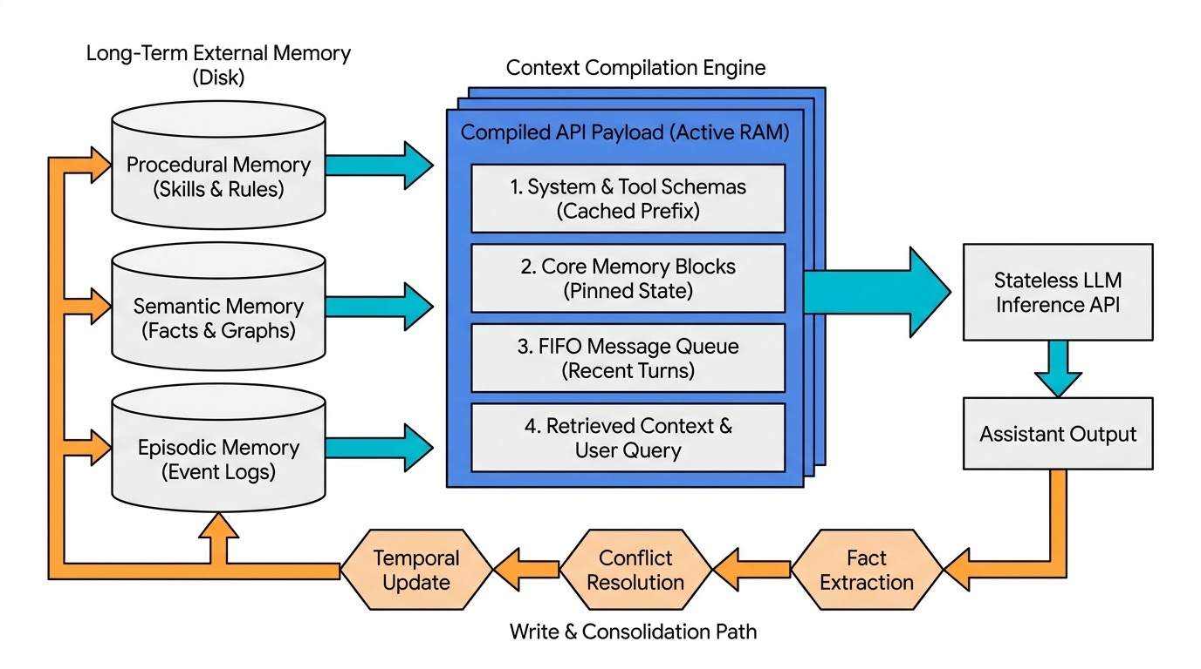

Short-Term Memory Architecture and Context Window Compaction
Short-term memory (STM)—frequently designated as working memory or active context—governs intra-session continuity¹. Rather than treating the context window as an unstructured text buffer, production frameworks model short-term memory after operating system virtual memory hierarchies, a paradigm pioneered by MemGPT (now Letta)³. In this architecture, the LLM's finite context window functions as physical random-access memory (Main Context), while external relational and vector databases act as unbounded disk storage (External Context)⁷.
Within the Main Context, prompt tokens are strictly partitioned into three contiguous regions⁷. At the top of the window sit the System Instructions, which house read-only foundational directives, behavioral constraints, and function-calling schemas that define the operational environment³. Immediately following the system preamble is the Working Context (Core Memory Blocks), which consists of persistent, character-bounded, in-context data blocks—typically labeled persona (defining the agent's evolving self-state) and human (capturing high-priority user attributes, active goals, and preferences)³. Because these blocks are pinned directly inside the context window on every turn (often capped at configurable limits such as 5,000 characters per block), the model has zero-latency visibility into them and can directly rewrite them via dedicated self-editing tool calls (core_memory_append and core_memory_replace)³. The remainder of the active window is occupied by the FIFO Message Queue, a first-in, first-out rolling buffer containing recent conversational turns, intermediate inner-monologue traces, and recent tool execution outputs³.

Context Overflow and Compaction Mechanics
As an interaction progresses across dozens of turns or multi-step tool executions, the FIFO queue expands toward the context budget limit⁶. When token utilization crosses a predefined watermark—typically configured between 75% of the context limit (with a minimum floor of 50,000 tokens in enterprise harnesses like TrueForge) and 83.5% of the window (in coding harnesses like Claude Code)—the runtime triggers Memory Compaction³.

Compaction Strategy | Operational Mechanism | Information Fidelity & Cost Trade-Off | Representative Implementations
Sliding Window (FIFO Eviction) | Retains only the most recent turns or tokens; older messages are truncated and flushed to external recall storage⁶. | Zero summarization latency or compute cost, but suffers total loss of early session context unless explicitly retrieved later⁶. | LangChain ConversationBufferWindowMemory, ConversationTokenBufferMemory, Letta default sliding window³.
Recursive LLM Summarization | Evicted message batches are passed to a fast secondary model (e.g., claude-haiku) to generate a dense summary block injected before recent turns⁶. | Preserves high-level narrative continuity at the cost of an auxiliary LLM call; lossy regarding granular syntax or exact figures⁶. | LangChain ConversationSummaryBufferMemory, Claude Code compaction_result block⁶.
Tool-Result Offloading | Strips bulky raw tool outputs (e.g., file dumps, terminal logs, API JSON payloads) from prior turns while keeping the assistant's analytical summary⁶. | Reclaims massive token volume with minimal loss of conversational intent, as raw payloads are rarely needed after initial synthesis⁶. | Timbal Agent Harness, Tiered/Hybrid Compaction Pipelines⁶.
Persistent Context Graphs | Compacts historical dialogue and code edits into a structured, queryable entity-relation graph rather than a flat text summary⁸. | Halves historical context tokens per call while improving multi-turn accuracy by 19.8 to 41.2 points on Lost-in-Conversation benchmarks⁸. | Persistent Context Graphs (Yang et al., 2026)⁸.
While compaction prevents hard context-overflow errors, it introduces two severe second-order vulnerabilities: Context Rot and Governance Decay (Retention Inversion)⁶. Context rot occurs when iterative summarization strips away subtle edge cases or implicit assumptions, leaving the model operating on over-generalized abstractions without recognizing what details were discarded⁶. Governance decay occurs when safety policies, operational boundaries, or formatting constraints are supplied in early conversational turns rather than anchored in the immutable system prompt; when compaction summarizes those early turns, the safety constraints are silently compressed away⁶. Production harnesses mitigate governance decay through three structural safeguards: anchoring all invariant policies strictly inside the system prompt, maintaining explicit string preserve-lists that bypass summarization, and exposing compaction as a first-class typed API block (as in Claude Code) or meta-harness policy trigger (as in Omnigent) that automatically re-injects security constraints immediately following a compaction event⁶.

Feeding Memory Back to the API Call: Context Compilation and Prefix Caching
Because an LLM API accepts only a linear sequence of token blocks, storing data in vector databases or knowledge graphs accomplishes nothing until that state is serialized back into the API call¹. In modern agent engineering, this serialization step is termed Context Compilation (Memory.compile())—the runtime process that treats the prompt not as a static string template, but as a compiled runtime view assembled just prior to inference³.

The Tension Between Transformer Attention and Prompt Caching Economics
When designing the payload structure to feed memory back into the API call, architects must balance two competing physical constraints: positional attention bias and prefix caching mechanics¹⁰. Transformer models exhibit strong primacy and recency biases, allocating the highest attention weights to tokens at the very beginning and very end of the context window while underweighting information buried in the middle ("lost in the middle")¹⁰. Simultaneously, model providers (including Anthropic and OpenAI) implement server-side Prompt Caching (KV-cache reuse) by computing cumulative cryptographic hashes of the prompt prefix starting from the very first token (tools system messages)¹¹. If the leading prefix of a new API call matches a cached prefix from a recent turn (typically within a 5-minute or 1-hour time-to-live), the provider skips prefill computation for those tokens, reducing input token costs by 50% to 90% and drastically cutting latency³³.
Crucially, prefix caching operates on strict byte-for-byte prefix identity³³. If an application dynamically injects newly retrieved long-term memories, changing timestamps, or variable JSON schemas into the top of the system prompt on every turn, the cumulative prefix hash changes at the root³³. This invalidates the entire prompt cache, forcing the application to pay full compute and latency penalties for the entire conversation history on every single message⁴⁶.
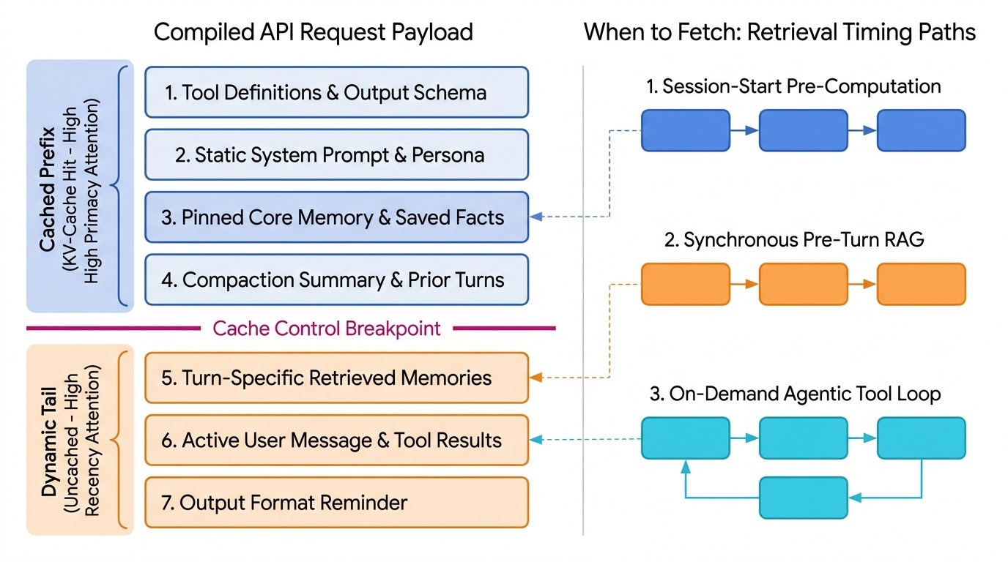

Canonical API Payload Ordering and Injection Architecture
To resolve the conflict between attention physics and prefix caching, production context compilers enforce a strict Stable-First, Variable-Last ordering within the API request body¹¹. At the absolute root prefix of the request sit the Tool Definitions and Reusable Output Schemas³³. Because mutating a structured output JSON schema invalidates everything after it, advanced implementations consolidate all turn schemas into a single constant union schema across the session, instructing the model to populate only the relevant fields per turn⁴⁸. Immediately following the tool schemas is the Static System Prompt and Procedural Directives block, which houses the agent's core identity, behavioral rules, negative constraints, and stopping conditions¹¹. This block is kept strictly immutable across turns so it remains permanently cached⁴⁶.
Beneath the static system instructions, the compiler places Session-Stable User Memory and Pinned Context Blocks, which hold curated long-term facts and persona states—such as Letta's human and persona blocks, OpenClaw's SOUL.md, USER.md, and MEMORY.md files, or ChatGPT's saved user memories³. By updating these blocks only at session initialization—or selectively when an explicit memory-write tool is called—the prefix remains stable across standard conversational turns³⁰. Next in the sequence is the Compaction Summary and Rolling Conversation History³. When automatic prefix caching is enabled, the provider places an advancing cache_control breakpoint at the end of the prior turn's message history, looking back up to 20 blocks to match previously cached conversation prefixes³³. Finally, at the very bottom of the payload sits the Dynamic Turn-Specific Retrieved Context and Tool Outputs (The Uncached Tail)¹¹. Any episodic or semantic memories fetched specifically for the current user query—or returned via an on-demand tool call (tool_result)—are injected at the end of the message array, immediately adjacent to the current user message and final output format reminders¹¹. This placement guarantees that dynamic retrieval never rewrites the cached history prefix while positioning the retrieved facts inside the high-attention recency zone¹¹.

Production Case Studies: How Leading Platforms Compile Context
Different production systems make distinct architectural bets on how long-term memory is structured and injected into the context window¹⁵:

Platform / Framework | Memory Representation Substrate | Context Injection & Compilation Mechanism | Consolidation & Maintenance Model
OpenAI ChatGPT | Dual-layer: (1) Flat list of discrete saved text facts (User Memory), and (2) implicit cross-chat pattern models (Reference Chat History)³⁰. | Pre-computes summaries to bypass real-time search latency; injects 4 layers into every call: Session Metadata Saved Facts Recent Conversations Summary Current Session Messages³⁰. | Explicit extraction during chat ("Memory updated") plus an opaque background "dreaming" consolidation pass to resolve contradictions⁴⁹.
Anthropic Claude | Project-scoped and global structured, wiki-style documents rather than isolated one-line snippets⁴⁹. | Compiles the structured wiki brief directly into the prompt context, offering high readability and manual auditability⁴⁹. | Automated nightly consolidation cycle that distills daily conversational learnings into the structured memory document⁴⁹.
OpenClaw | Transparent, user-editable local Markdown file stack: SOUL.md (identity), USER.md (profile), MEMORY.md (curated LTM), and memory/YYYY-MM-DD.md (daily logs)¹⁵. | Deterministic file-loading pipeline that injects the Markdown hierarchy into the system context at conversation startup¹⁵. | Continuous agent distillation of daily YYYY-MM-DD.md working notes into MEMORY.md, coupled with direct human file editing¹⁵.
Letta (MemGPT) | Stateful database storing editable in-context Core Memory blocks alongside out-of-context Recall and Archival vector/table stores³. | Memory.compile() serializes system instructions, character-bounded core blocks, external metadata summaries, and the FIFO message queue³. | Autonomous agent self-management via tool calls (core_memory_replace, archival_memory_insert) and message compaction³.

Retrieval Orchestration: When to Fetch and How to Score
Determining when to query external long-term memory and which candidate records to admit into the prompt represents a primary latency-accuracy trade-off in conversational systems¹.

Three Retrieval Timing Paradigms
Architects govern read-path timing through three primary orchestration patterns, often combining them across different memory tiers³. The first pattern is Session-Start Pre-Computed Injection (Zero-Turn-Latency Pattern), in which the system avoids executing a database query on every user message by pre-fetching a bounded set of high-priority user facts and pre-computed summaries of recent sessions when the chat session initializes¹⁵. As demonstrated by reverse-engineering analyses of ChatGPT, injecting all ~33 saved user facts and a pre-computed interest summary directly into the context window eliminates per-turn retrieval latency entirely³⁰. However, this pattern scales poorly once a user accumulates thousands of historical episodes or complex relational data, as flat lists quickly exhaust token budgets and suffer from contradiction accumulation¹⁵.
The second timing paradigm is Synchronous Pre-Turn Interception (Application-Driven RAG Pattern)³. Under this approach, on every user turn—prior to calling the primary LLM—the backend intercepts the user's message, converts it into an embedding vector (or structured graph query), searches the external long-term memory store, and injects the top- scored memories into the dynamic tail of the prompt³. While pre-turn interception guarantees that relevant historical context is immediately available for single-pass generation, it imposes a mandatory latency floor (typically 150 ms to 500 ms) on every turn and wastes compute when the user utterance is trivial, such as a simple acknowledgment or formatting request¹.
To eliminate unnecessary per-turn lookups while preserving access to unbounded archival storage, modern stateful agents increasingly adopt the third paradigm: On-Demand Agentic Retrieval (Tool-Driven / Just-in-Time Pattern)³. Instead of forcing the application layer to guess what context is needed before the LLM sees the prompt, the system disables automatic pre-turn memory injection and exposes external memory as a suite of callable tools—such as archival_memory_search, recall_storage.search, query_chat_files, or grep_chat_files³. When a user asks a question that requires historical recall (for example, referencing a database migration discussion from the prior week), the LLM recognizes its own knowledge gap and emits a structured tool call³. The runtime executes the search, appends the paginated results as a tool_result message at the end of the conversation (preserving the cached system prefix), and utilizes a continuation flag (a processor "heartbeat") to immediately re-invoke the LLM so it can synthesize the final answer¹⁷.

Multi-Signal Retrieval Scoring: Beyond Vector Similarity
When a synchronous or agentic search queries long-term memory, ranking candidates solely by vector cosine similarity produces systematic conversational failures¹⁰. Vector similarity measures semantic proximity rather than contextual utility¹⁰. For instance, if a user asks, "Where should we go for dinner tonight?", pure vector search will rank passing mentions of five restaurants from eight months ago at the top of the candidate list because they share strong semantic overlap with "dinner," while failing to surface a critical allergy or dietary restriction phrased in dissimilar vocabulary¹⁰. Conversely, sorting strictly by recency overrides a permanent, months-old dietary rule with a casual mention of pizza from two days prior¹⁰.
To overcome single-signal failure modes, production memory architectures implement the Tri-Factor Retrieval Scoring Model formalized by Park et al. in the Generative Agents architecture, which evaluates every candidate memory record across three orthogonal dimensions normalized to the range via min-max scaling¹⁰:
The first component, Recency (Temporal Decay), prioritizes memories that were created or last accessed recently, modeled via an exponential decay function , where represents the elapsed hours since last retrieval and is a decay constant typically set between and ²¹. The second component, Importance (Durability / Poignancy), captures the intrinsic, query-independent significance of a memory record assigned at the moment the memory is written¹⁰. While research prototypes use an LLM prompt at write-time to rate poignancy on an integer scale of to (scoring mundane remarks like eating breakfast as – and major life events or explicit constraints as –)²², production engineering favors hybrid assignment: deterministic structural rules automatically assign maximum importance scores to explicit user corrections, stated preferences, and standing instructions, reserving LLM scoring calls for ambiguous conversational turns¹⁰. The third component, Relevance (Contextual Alignment), measures proximity between the current situational query and the stored memory²¹. While baseline systems compute relevance purely via embedding cosine similarity²¹, enterprise engines like Zep / Graphiti replace single-vector lookup with a unified hybrid retrieval pass that combines dense semantic embeddings (1024D cosine distance), sparse keyword matching (BM25 full-text search), and breadth-first graph traversal (reranking by hop-distance from a central entity node) in roughly 155 ms to 162 ms without requiring slow LLM-in-the-loop rerankers²⁴.
When tuning the weighting coefficients (), engineers calibrate starting from equal weights () based on the agent's operational domain: elevating for live conversational continuity, raising for personal assistants that must enforce months-old constraints, and prioritizing for research and lookup workflows¹⁰. Crucially, retrieval selection enforces strict precision over recall—admitting only a small handful of top-scoring records into the prompt so that low-confidence or stale facts do not pollute generation¹⁰.

The Write Path: Extraction, Temporal Conflict Resolution, and Consolidation
A chatbot's long-term memory degrades rapidly if the write path acts as an append-only dump¹⁵. Human states, project architectures, and preferences mutate over time; a user who states "I code primarily in Python" in January and "I migrated my stack to Rust" in March will experience hallucinated, contradictory assistance if both statements coexist with equal validity in the memory store¹.

Write-Path Timing and Deduplication Pipelines
Memory writes occur across two temporal tracks: Synchronous In-Loop Writes and Asynchronous Post-Turn Pipelines³. In synchronous self-editing architectures (such as Letta), the LLM explicitly invokes a memory-mutation tool during turn generation when the user issues a direct command (e.g., "Remember that my deployment deadline is Friday")³. However, relying solely on synchronous self-editing increases user-facing latency and misses implicit facts²³. Consequently, dedicated memory layers like Mem0 and Zep execute extraction asynchronously in the background after the assistant response is streamed to the user, utilizing staged worker queues and concurrency semaphores (such as Graphiti's SEMAPHORE_LIMIT) to avoid provider rate limits²³.
Within Mem0's hybrid architecture—which combines vector embeddings for fast semantic lookup, a graph store to prevent relational drift, and a key-value store for fast attribute access—every add() operation passes through a three-stage lifecycle pipeline²⁵. First, during Atomic Fact Extraction, an extraction prompt parses raw conversational turns into discrete, self-contained candidate facts and entity relationships⁵⁸. Second, during Semantic Deduplication, the pipeline queries the vector and graph stores for existing memories that are semantically proximate to the newly extracted candidates⁵⁸. If a user repeats an already known preference, the system recognizes the repetition and reinforces the existing record's importance and recency metadata rather than creating duplicate entries³⁴. Third, during LLM-Guided Conflict Resolution, when a new candidate fact contradicts or modifies an existing record, a specialized resolution classifier (or reinforcement-learned controller as in Memory-R1) selects an explicit state mutation operation—ADD (create new), UPDATE / MERGE (overwrite or synthesize state), DELETE (evict invalidated state), or NOOP (discard redundant noise)—maintaining store hygiene automatically¹. In production evaluations, Mem0 achieves 92.5% accuracy on the LoCoMo benchmark and 94.4% on LongMemEval¹.

Bi-Temporal Knowledge Graphs and Non-Lossy Edge Invalidation
While overwriting outdated facts in a vector database keeps the current state clean, it destroys historical lineage—making it impossible for an enterprise agent to answer temporal progression queries such as "What was the client's billing tier before the Q1 upgrade?"²³. To solve this without relying on slow, lossy LLM summarization, Zep and its open-source Graphiti engine implement a Bi-Temporal Dynamic Knowledge Graph organized across three hierarchical subgraphs¹⁸. At the foundation sits the Episode Subgraph (), a non-lossy ground-truth store where every raw message, JSON payload, or document chunk is stored as an episodic node annotated with a reference timestamp (), allowing the system to resolve relative time expressions like "next Thursday" or "last summer"¹⁸. Above the episodic layer sits the Semantic Entity Subgraph (), where extracted entities and multi-entity hyperedges are connected back to their source episodes via bidirectional provenance indices, enabling instant citation tracebacks¹⁸. At the highest level sits the Community Subgraph (), which groups strongly connected entities into high-level domain clusters maintained continuously via dynamic label propagation, capturing macro-level user and project summaries²⁴.
Every relational edge in Graphiti carries four timestamps governed by a bi-temporal model tracking Event Time () (chronological reality) and Ingestion Time () (transactional database lineage)¹⁸. Along the chronological timeline, edges record and to capture when a fact actually became true and when it ceased to be true in the real world²⁴. Along the transactional timeline, edges record and to audit when the memory engine first recorded the fact and when it learned that the fact was superseded²⁴.
When new conversational evidence arrives—for example, a user stating they left Acme Inc. to join Globex Corp. in March 2026—an Invalidation Agent evaluates incident edges on the graph²³. Rather than deleting the prior record, it sets on the works_at("Acme Inc.") edge and inserts a new active edge for works_at("Globex Corp.")²⁴. Current-state queries automatically filter for active edges (), while historical or audit queries traverse the preserved temporal lineage²⁴. Across production benchmarks, Zep / Graphiti achieves 94.7% accuracy on LoCoMo (at 155 ms retrieval latency), 90.2% overall accuracy on LongMemEval (at 162 ms retrieval latency with a compact 4,408-token context footprint), and 63.8% on specialized temporal reasoning subsets within LongMemEval, while reducing streaming update latency by 90% compared to static RAG baselines²⁴.
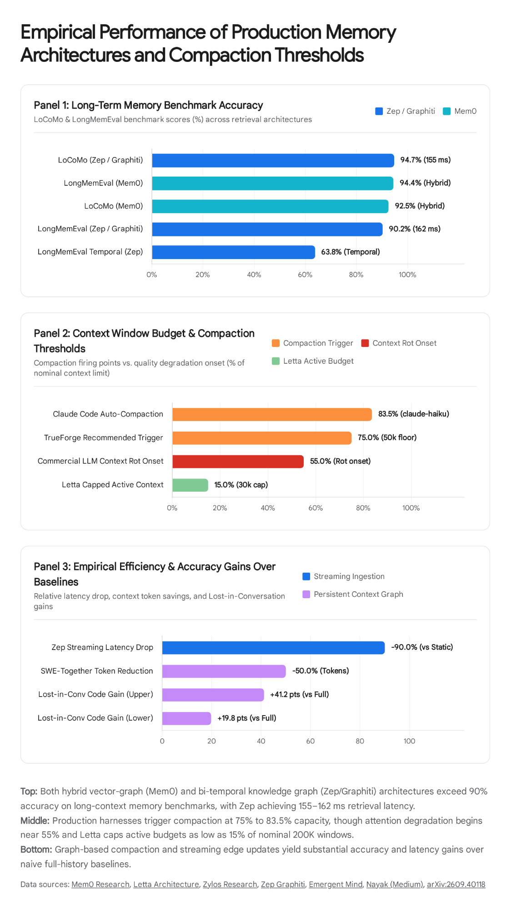

Biological Consolidation, Reflection Trees, and Selective Forgetting
Even with conflict resolution, agents that accumulate thousands of raw episodic observations struggle to generalize higher-level behavioral patterns²². Furthermore, unbounded memory growth degrades retrieval precision as obsolete trivia competes with durable knowledge¹⁰. Advanced architectures address this through Memory Consolidation and Selective Forgetting modeled on human hippocampal-neocortical transfer³².
In the Generative Agents paradigm, higher-order generalization is achieved via Threshold-Triggered Reflection Trees, where every incoming observation's importance score is added to an accumulator²². When the cumulative importance sum exceeds a predefined threshold (such as ), the agent pauses to execute an offline reflection routine²². It inspects its 100 most recent episodic records, prompts the LLM to formulate the three most salient high-level questions about those events, uses those questions as retrieval queries across its entire memory stream, and synthesizes abstract second-order conclusions²¹. These reflections are written back into the memory stream as non-leaf nodes in a hierarchical tree structure, allowing future retrievals to access both raw leaf observations and synthesized behavioral generalizations²².
Beyond semantic reflections, production agents perform Procedural Distillation and Continuum Memory Updates by extracting Workflow Memories from successful multi-step tool executions⁴. By recording the exact sequence of tool calls, arguments, and outcomes as embedded procedural templates (MemoryType.WORKFLOW_MEMORY), the agent retrieves proven execution blueprints during future analogous tasks⁴. Emerging continuum memory architectures (such as Nested Learning / CMS and Hindsight) further separate evidence from beliefs, updating memory blocks across multi-timescale frequency tiers so rapid corrections occur without catastrophic forgetting of core habits⁶³.
Simultaneously, in long-horizon production systems, Ebbinghaus Forgetting Curves and Graph Sparsification ensure that forgetting operates as a deliberate optimization feature rather than a storage bug⁶⁵. Neuro-inspired frameworks (such as FSFM) and enterprise graph archival policies assign a composite retention score to every memory record or graph edge based on the product of recency, trust, and query frequency ()²³. Following Ebbinghaus trace-decay dynamics, episodic memories that are never re-accessed or reinforced across subsequent sessions decay below an activation floor and are either compacted into coarse semantic summaries or moved to cold archival storage, keeping the active retrieval index sparse, fast, and high-precision²³.

Architectural Synthesis and Implementation Recommendations
Designing a production chatbot memory system requires aligning the memory topology with the application's temporal horizon, latency ceiling, and auditability requirements¹. Architects should first decouple prompt prefix stability from dynamic retrieval by never injecting turn-specific retrieved memories or volatile timestamps into the top-level system prompt¹¹. Instead, anchoring static instructions, tool definitions, and session-stable user profiles above an explicit cache_control breakpoint captures 50% or greater prefix caching discounts, while appending turn-specific retrieved context or tool outputs at the bottom of the message array positions dynamic data where transformer recency attention is strongest¹¹.
Furthermore, engineering teams should match retrieval timing to query complexity by hybridizing the read path³. Compact, high-importance identity and preference blocks (USER.md or Core Memory) should be loaded unconditionally at session initialization for zero-latency personalization, whereas deep historical or archival lookup should be delegated to on-demand agentic tool calls (archival_memory_search) whenever multi-step latency is acceptable, ensuring database queries only execute when the model identifies a context gap³.
On the persistence and write path, production systems must abandon append-only vector dumps in favor of bi-temporal knowledge graphs or hybrid lifecycle stores¹⁰. If an application requires fast preference personalization with minimal infrastructure overhead, deploying a hybrid vector-graph-KV layer with automated write-path deduplication and conflict resolution (such as Mem0) maintains store hygiene seamlessly¹. Conversely, if the domain involves frequently mutating relationships, multi-hop reasoning, or strict regulatory auditability—such as financial advisory, healthcare coordination, or enterprise customer relationship management—deploying a bi-temporal knowledge graph (such as Zep / Graphiti) preserves full historical validity windows via non-lossy edge invalidation²⁴. Finally, context window compaction must be hardened against governance decay by triggering compaction proactively at 75% to 80% of the effective token budget—offloading verbose tool results before summarizing dialogue—and strictly isolating safety policies and output contracts inside the immutable system prompt or an automated post-compaction re-injection hook so critical operational constraints are never summarized out of existence⁶.

Works cited
- AI Agent Memory: Complete Guide & Architecture - Mem0, https://mem0.ai/library/agent-memory/memory-in-agents-what-why-and-how
- Memory Mechanisms in LLMs - Emergent Mind, https://www.emergentmind.com/topics/memory-mechanisms-in-llms
- The Engineering Divide from MemGPT to Letta - Neat Guy Coding, https://neatguycoding.com/posts/2026-05-18-weaviate-podcast-letta-ai-with-sarah-wooders-weaviate-podcast-117/
- What Is Agent Memory? A Guide to Enhancing AI Learning and Recall, https://www.mongodb.com/resources/basics/artificial-intelligence/agent-memory
- What if your LLM had RAM, Disk, and a Memory Manager?, https://shilpathota.medium.com/what-if-your-llm-had-ram-disk-and-a-memory-manager-486a0c9240d4
- Memory Compaction in AI Agent Harnesses: | by Plaban Nayak, https://nayakpplaban.medium.com/memory-compaction-in-ai-agent-harnesses-ce0ac91b85fa
- MemGPT Giving LLMs Unbounded Context Size - Medium, https://medium.com/@jf_rezkellah/memgpt-giving-llms-unbounded-context-size-a51157522313
- Persistent Context Graphs for Efficient Memory Compaction in LLM, https://arxiv.org/abs/2609.40118
- Context Engineering for AI Agents - AY Automate, https://www.ayautomate.com/blog/context-engineering
- Memory Scoring and Ranking for AI Agents, https://aimemoryworks.com/architecture/memory-scoring/
- Context Engineering 2026: Complete Guide to Designing What Your, https://explainx.ai/blog/context-engineering-clean-prompts-generator-2026
- Cognitive Architectures for AI Agents (CoALA): Explained - Cognee, https://www.cognee.ai/cognitive-architectures-for-language-agents-explained
- Types of AI Agent Memory: Sensory to Long-Term Explained - Mem0, https://mem0.ai/library/agent-memory/how-memory-shapes-us-a-deep-dive-into-the-types-of-memory
- The Four Types of Memory Every AI Agent Needs | daily.dev, https://daily.dev/posts/the-four-types-of-memory-every-ai-agent-needs-mdol0zbbp
- How AI Memory Actually Works (and Why OpenClaw's Is Different), https://www.lobsterfarm.ai/guides/how-ai-memory-works/
- The 4 AI Agent Memory Types That Change EVERYTHING (CoALA, https://www.youtube.com/watch?v=_OrkYRPQrzU
- MemGPT: Towards LLMs as Operating Systems - arXiv, https://arxiv.org/pdf/2310.08560
- Zep: A Temporal Knowledge Graph Architecture for Agent Memory, https://arxiv.org/html/2501.13956v1
- The Five Types of Memory Every AI Agent Needs - ClairX, https://www.clair-x.ai/insights/the-five-types-of-memory-every-ai-agent-needs
- Building Robust AI Agents: Insights from CoALA Paper - Medium, https://medium.com/vaibhav31/building-robust-ai-agents-insights-from-coala-paper-3a87324f3438
- [Paper reading] Generative Agents: Interactive Simulacra of Human, https://blog.yujieliu.com/blogs/paper-reading/Generative%20Agents_%20Interactive%20Simulacra%20of%20Human%20Behavior.html
- Generative Agents: Interactive Simulacra of Human Behavior, https://3dvar.com/Park2023Generative.pdf
- Temporal Agents with Knowledge Graphs - OpenAI Developers, https://developers.openai.com/cookbook/examples/partners/temporal_agents_with_knowledge_graphs/temporal_agents
- Zep: Temporal Knowledge Graph Architecture - Emergent Mind, https://www.emergentmind.com/topics/zep-a-temporal-knowledge-graph-architecture
- Long-Term Memory for AI Agents: The What, Why and How - Mem0, https://mem0.ai/library/agent-memory/long-term-memory
- The Four Types of Memory for AI Agents (and How Claude Code, https://alexop.dev/posts/four-types-memory-coding-agents-claude-code/
- getzep/graphiti: Build Real-Time Knowledge Graphs for AI Agents, https://github.com/getzep/graphiti
- What Is Agent Memory Infrastructure? How Mem0 Beats OpenAI's, https://www.mindstudio.ai/blog/agent-memory-infrastructure-mem0-vs-openai
- Graphiti | Zep, https://www.getzep.com/platform/graphiti/
- How ChatGPT Memory Works, Reverse Engineered - LLMrefs, https://llmrefs.com/blog/reverse-engineering-chatgpt-memory
- Cognitive Architectures for Language Agents - arXiv, https://arxiv.org/html/2309.02427v3
- Semantic Memory Consolidation in Production AI Agents, https://www.llms.blog/posts/semantic-memory-consolidation-in-production-ai-agents-architecture-episodic-decay-curves-and-procedural-knowledge-distillation
- Prompt caching - Claude Platform Docs, https://platform.claude.com/docs/en/build-with-claude/prompt-caching
- RAG vs. Memory: What AI Agent Developers Need to Know - Mem0, https://mem0.ai/library/agent-memory/rag-vs-ai-memory
- Graphiti: Knowledge Graph Memory for an Agentic World - Medium, https://medium.com/neo4j/graphiti-knowledge-graph-memory-for-a-post-rag-agentic-world-0fd2366ba27d
- Agent Memory in 2026: Mem0 vs Zep vs Letta vs LangMem, https://maidul-haque.vercel.app/blog/agent-memory-architectures-2026/
- MemGPT/Letta - Long-term Memory Management - Wiki - clawbot.ai, https://clawbot.ai/wiki/voice-memory/memgpt-letta-long-term-memory-management.html
- ConversationBufferWindowMem, https://langchain-cn.readthedocs.io/en/latest/modules/memory/types/buffer_window.html
- Sliding Window and Summarization Methods - MantraMindAI, https://www.mantramindai.in/courses/context-management-and-memory/lessons/sliding-window-and-summarization-methods
- LangChain ConversationBufferMemory: Complete Implementation, https://latenode.com/blog/ai-frameworks-technical-infrastructure/langchain-setup-tools-agents-memory/langchain-conversationbuffer-memory-complete-implementation-guide-code-examples-2025
- How Does LLM Memory Work? Building Context-Aware AI, https://www.datacamp.com/blog/how-does-llm-memory-work
- LangChain Memory Optimization: Cut AI Costs by 40%, https://propelius.tech/blogs/langchain-memory-optimization-for-ai-workflows/
- Memory Compaction - Timbal AI, https://docs.timbal.ai/agents/memory-compaction
- REMORY: Learning Residual Memory for Context Compaction, https://huggingface.co/papers/2610.11287
- LangGraph Compaction Deletes the View, Not the Record, https://ranjankumar.in/langgraph-context-memory-retention-inversion
- Prompt Caching (KV Cache) Optimization - Open WebUI, https://docs.openwebui.com/features/chat-conversations/prompt-caching/
- OpenAI Prompt Prefix Caching — AI Engineering Academy | CoddyKit, https://www.coddykit.com/courses/learn_ai_engineering/openai-prompt-prefix-caching-10619599
- Prompt Caching Hierarchy with Structured Outputs - Feedback, https://community.openai.com/t/prompt-caching-hierarchy-with-structured-outputs/968620
- How to Use Claude Memory vs ChatGPT Memory - MindStudio, https://www.mindstudio.ai/blog/claude-memory-vs-chatgpt-memory-comparison
- ChatGPT Memory: How It Works, What It Remembers ... - Edurancehub, https://edurancehub.co.in/chatgpt-memory/
- ChatGPT Settings Guide: Customize Your AI Experience, https://www.ai-toolbox.co/chatgpt-management-and-productivity/chatgpt-settings-customize-ai-2026
- Generative Agents: Interactive Simulacra of Human Behavior ... - note, https://note.com/mega_gorilla/n/n63b77b6ef6a3?hl=en
- Generative Agents: Interactive Simulacra of Human Behavior - arXiv, https://arxiv.org/html/2304.03442v2
- Generative Agents: Interactive Simulacra of Human Behavior, https://abhinavchinta.com/files/generative_agents_talk.pdf
- Overview | Zep Documentation, https://help.getzep.com/graphiti/getting-started/overview
- AI Agent Memory: Build vs. Buy - Mem0, https://mem0.ai/library/agent-memory/ai-agent-memory-build-vs-buy
- How memory works in AI chatbots - Mem0, https://mem0.ai/library/agent-memory/how-memory-works-in-ai-chatbots
- Memory System | mem0ai/mem0 - DeepWiki, https://deepwiki.com/mem0ai/mem0/3-memory-system
- FadeMem: Why Teaching AI Agents to Forget Makes ... - CORe Inc., https://co-r-e.com/method/agent-memory-forgetting
- Message Indexing And Memory Capture For AI Agents - Mem0, https://mem0.ai/library/agent-memory/message-indexing-and-memory-capture-for-ai-agents
- Mem0: The Complete Guide to Building AI That Actually Remembers, https://abhihyder.medium.com/mem0-the-complete-guide-to-building-ai-that-actually-remembers-c913c8c4d496
- Memory Consolidation in Long-Running AI Agents | Zylos Research, https://zylos.ai/research/2026-04-20-memory-consolidation-ai-agents/
- lhl/agentic-memory - GitHub, https://github.com/lhl/agentic-memory
- Graphiti - Learn AI, https://ai.miraheze.org/wiki/Graphiti
- The Agent's Memory Dilemma: Is Forgetting a Bug or a Feature?, https://tao-hpu.medium.com/the-agents-memory-dilemma-is-forgetting-a-bug-or-a-feature-a7e8421793d4
- FSFM: A Biologically-Inspired Framework for Selective Forgetting of, https://arxiv.org/html/2604.20300v2
- Memory eviction and forgetting in AI agents - Mem0, https://mem0.ai/library/agent-memory/memory-eviction-and-forgetting-in-ai-agents
- Selective Forgetting Agent Memory Biological (Grade A) - Claude Skill, https://www.skillsdirectory.com/skills/hiyenwong-selective-forgetting-agent-memory-biological-ai-collection
- FSFM: A Biologically-Inspired Framework for Selective Forgetting of, https://www.alphaxiv.org/abs/2604.20300

